Efficient Django Deployment :Dockerized Application on Azure VM

**Django Sample Application hello run in local environment:**

App running at local host

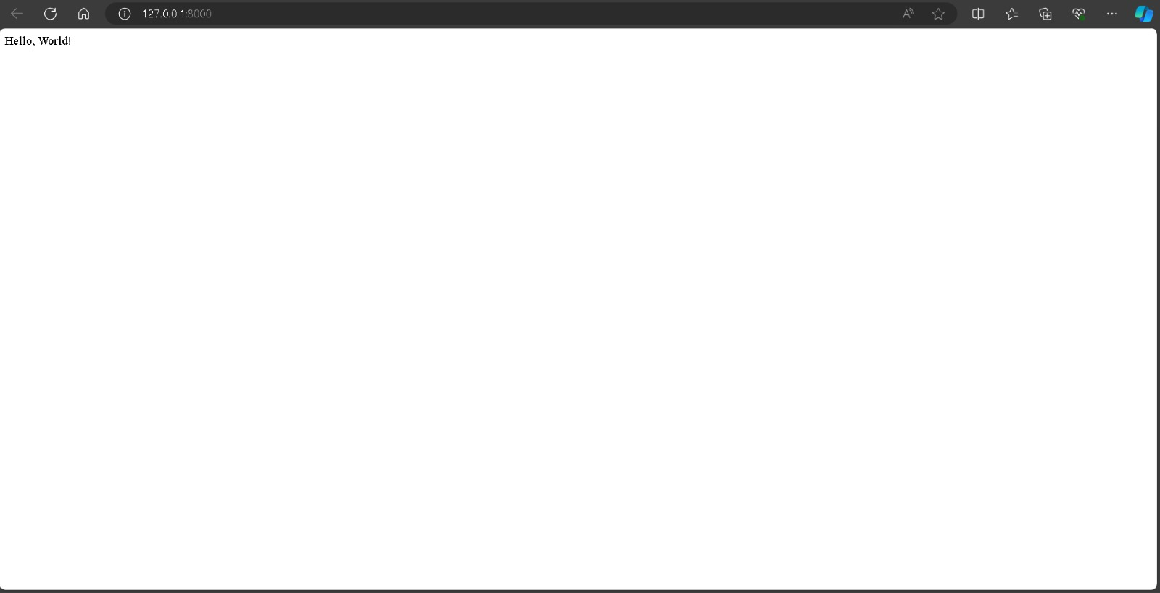

**Django application github link:** [**https://github.com/Prashant24081999/Incedo-AZMSSQL-Projects/tree/main/Django%20Project**](https://github.com/Prashant24081999/Incedo-AZMSSQL-Projects/tree/main/Django%20Project)

**Order and connect vm:**

az group create --name RgDockerProject --location eastus

az network vnet create --resource-group RgDockerProject --name MyVnet --address-prefix 10.0.0.0/16 --subnet-name MySubnet --subnet-prefix 10.0.0.0/24

az network nsg create --resource-group RgDockerProject --name MyNsg

az network nsg rule create --resource-group RgDockerProject --nsg-name MyNsg --name AllowSSH --priority 100 --destination-port-range 22 --direction Inbound --access Allow

az network public-ip create --resource-group RgDockerProject --name MyPublicIp --allocation-method Static

az network nic create --resource-group RgDockerProject --name MyNic --vnet-name MyVnet --subnet MySubnet --network-security-group MyNsg --public-ip-address MyPublicIp

**Creating VM**

az vm create \

--resource-group RgDockerProject \

--name myVM \

--image Ubuntu2204 \

--admin-username azureuser \

--authentication-type ssh \

--ssh-key-value ~/.ssh/id_rsa.pub \

--size Standard_DS2_v2 \

--nics MyNic \

--location eastus

--no-wait

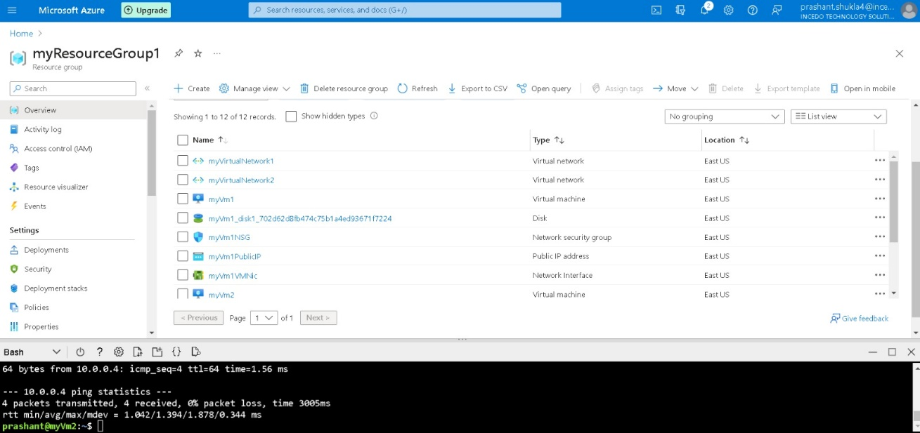

**Connect through ssh key:**

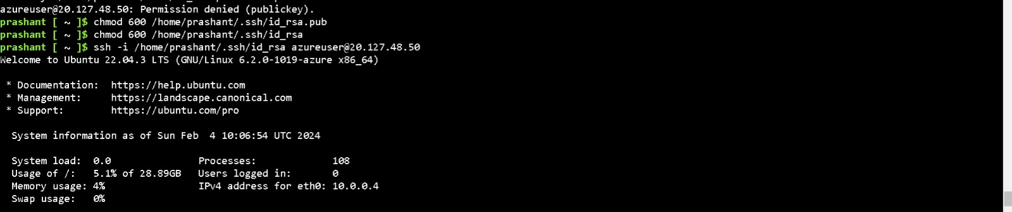

ssh-keygen -t rsa -b 2048 -C "prashantshukla1999@gmail.com"

cat ~/.ssh/id_rsa.pub

**Installing Docker on Azure VM:**

sudo apt update

sudo apt install -y apt-transport-https ca-certificates curl software-properties-common

curl -fsSL https://download.docker.com/linux/ubuntu/gpg | sudo gpg --dearmor -o /usr/share/keyrings/docker-archive-keyring.gpg

echo "deb [arch=amd64 signed-by=/usr/share/keyrings/docker-archive-keyring.gpg] https://download.docker.com/linux/ubuntu $(lsb_release -cs) stable" | sudo tee /etc/apt/sources.list.d/docker.list > /dev/null

sudo apt update

sudo apt install -y docker-ce docker-ce-cli containerd.io

docker --version

docker run hello-world

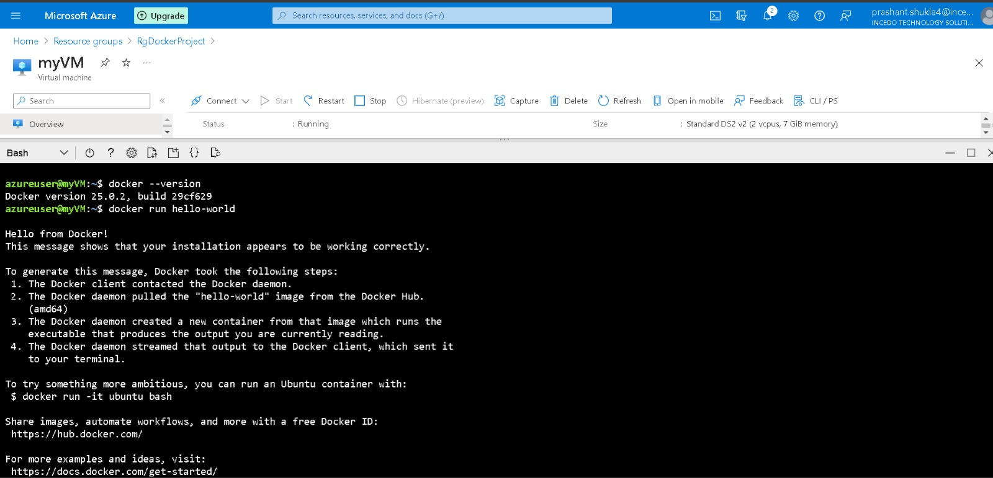

**Django Application Dockerization:**

Deployed the docker image at port 192.168.1.1/8000

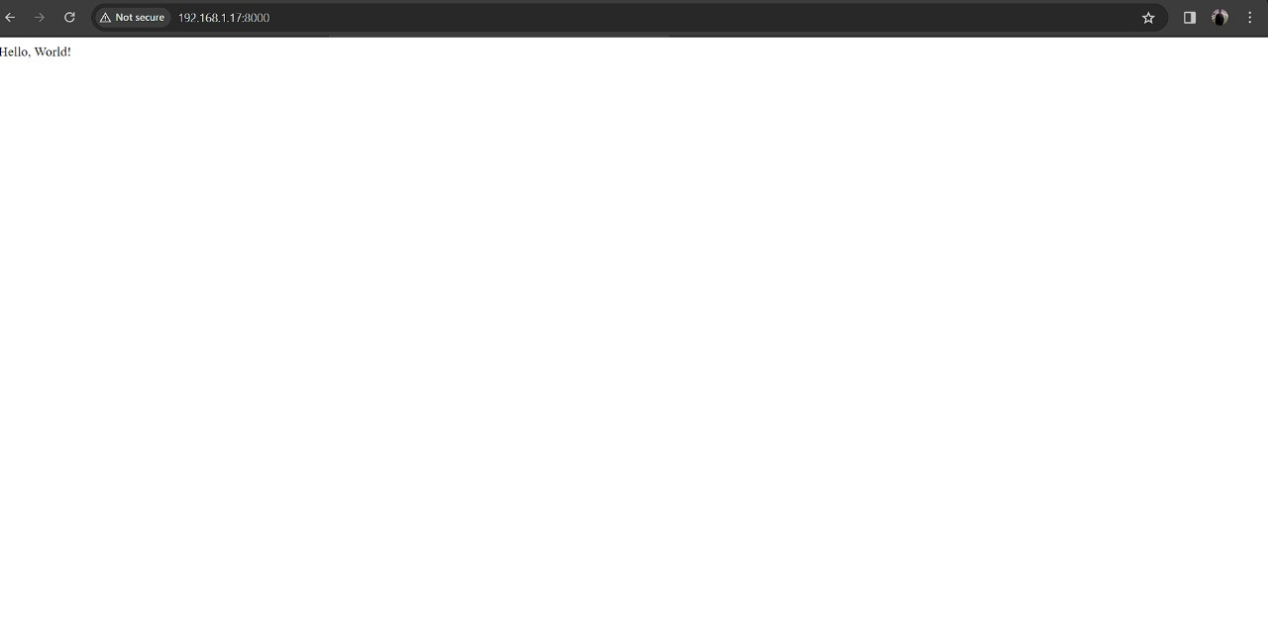

# Build the Docker image

docker build -t your-django-app .

# Run the Docker container

docker run -p 8000:8000 -it your-django-app

**Implementing security best practices(80,22,5001,443) for the Dockerized Django application.**

